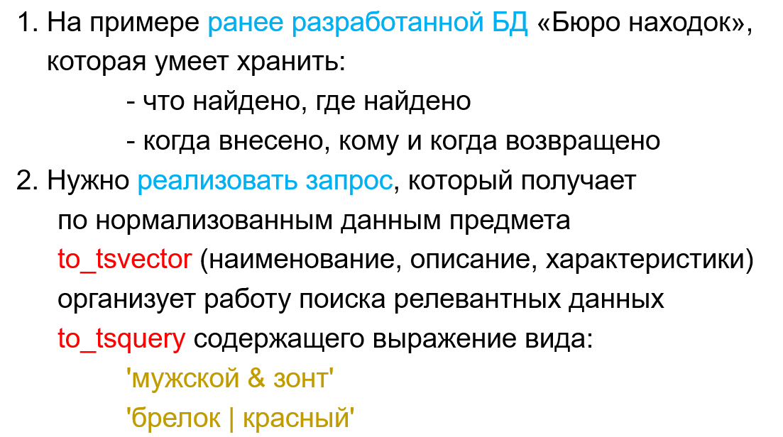
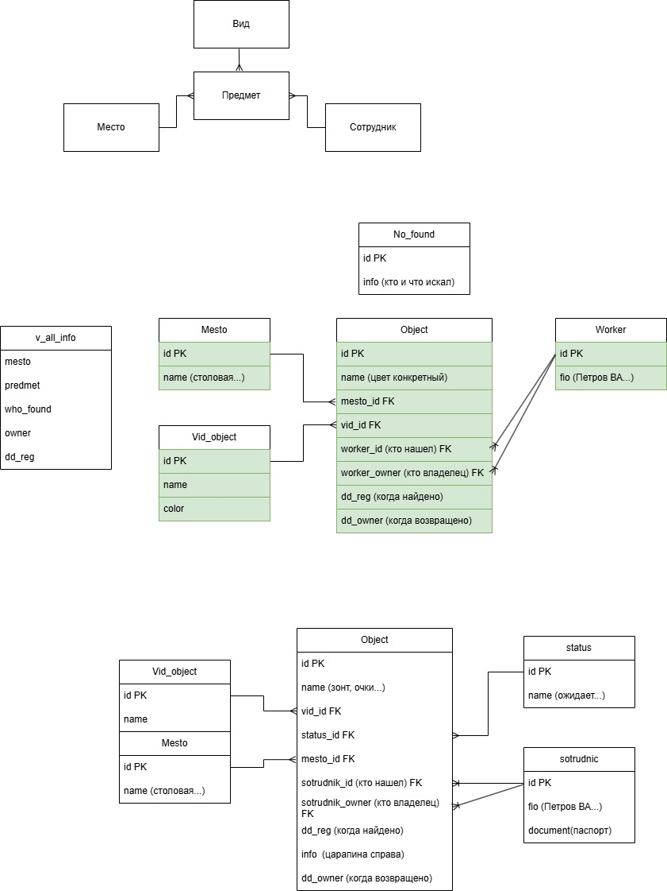
select predmet, mesto, to_tsvector('russian', mesto||' '||predmet||' '||owner)
from v_all_info

select to_tsquery('russian', 'шарф & туалет')

select * from v_all_info
where to_tsvector('russian', mesto||' '||predmet||' '||owner)
@@ to_tsquery('russian', 'шарф & улица')

